Modeling And Design Of A Dynamic Exoskeleton System With Various Speeds For Hemiplegic Patients

Elouarzi Abdelkarim, Sedra Moulay Brahim

**Abstract**: This paper introduces a dynamic exoskeleton system designed for hemiplegia people. The system purposes to help patients who suffer half body paralysis due to congenital causes, trauma, tumors, and stroke or caused by other illness. First, the mechanical system introduced through dynamical simulations in Catia. Second, the electronic circuit presented and detailed using a simulation in Proteus 8 and a modeling approach is proposed. Finally, an interaction system with a control algorithm proposed to help the patient to control the robot.

**Keywords**: Exoskeleton, Hemiplegic, Wearable Robotics, rehabilitation, Embedded System, handicap, disabled treatment.

————————————————————

1. **INTRODUCTION**

The number of disable people in the world is rising due to the huge number of car accident, wars, stroke, aging, tumors, congenital, spinal card injury (SCI), and other related diseases. In 2017 the OWH count more than one billion disabled people in the world. Only in Morocco, the government counts 1.2 Million disable citizens [1]. One of the most common sorts of disability is the hemiplegia, it’s defined as the paralysis of a side of the body, right or left, it is caused by disease or injury to the opposite hemisphere of the brain [2]. People with hemiplegia face many difficulties in mobility. These difficulties affect their ability to perform daily tasks, such as hygiene, self-care, driving, study and work…etc., which makes their lives depended to the others and create a negative impact on the quality of their life [3]. The traditional therapy for hemiplegic people includes medical treatment and physical rehabilitation. In order to improve the situation of disabled people many research team in the world work on robotic devices that can help the disabled patients to recuperate the mobility, to stand up and walk easily. Restoration of gait becomes a major goal in neurological rehabilitation. Many solutions are already available in the market, Mindwalker, Rewalk, HAL, e- Nable, Vanderbilt Exoskeleton, Ekso, CUHK-EXO…etc. However, that exoskeleton are oriented to paraplegic people, and only few solutions are developed for hemiplegic or tetraplegic patients. Moreover, the price of exoskeletons still too expensive and the majority of disable people cannot pay for it, especially in the poor countries, this solution consider a dream for those patients. Otherwise, the insurance companies do not reimburse exoskeletons. This price is too high because those solutions use a flat motor (Maxon EC90) with a harmonic drive gear (SHD or CSD) in each articulation, which increase the total price of the suit. For this reason, we develop in this research a low cost wearable exoskeleton suit titled NOD-H, designed to help hemiplegic patients exercise vital daily life tasks with a minimum price. Using two-gear motor RE 35, Ø 35 mm and a gearhead GP 42C, Ø 42 mm. In addition, compare his efficiency with other exoskeletons.

1. **MECHATRONIC DESIGN**

The main aim of the exoskeleton is to help the patients in the physical rehabilitation center to regain the normal mobility, but not all the patients achieve this objective, for this reason the exoskeleton mechatronic design must be for use in the rehabilitation center and in other places (home, office…etc.). The mechanical design must manufactured at low-cost, strong, lightweight, safe, and easy to use independently at home. The function of the dynamic exoskeleton system is to reproduce the motion of the safe leg to the sick leg, reading the speed and angle position by potentiometers in the unaffected leg and transfer the motion to the sick foot using the DC motors torque. The system consists of two sections, an active section attached to the paralyzed foot, and a passive section attached to the normal foot (fig.1).The passive section contains two potentiometers whose role is to read the speed and the rotation angle of the safe leg and transmit it to the microcontroller to generate the same motion on active section. The active section attached on the paralyzed foot on the left side consists of two DC gear motor, controlled by 50A dual-channel H bridge module and an Arduino Mega 2560 microcontroller board (fig.2).a screen and keypad is used to give the system the patient’s weight for optimize the torque provided. The DC motor rotor coupled to a small gear G1, this gear transmit the rotational motion to a train gear G2 with transmit the motion to the support S (fig.4) attached to the patient. A Double Torsion Spring used in the knee to reduce the motor energy.

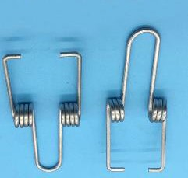Fig.3

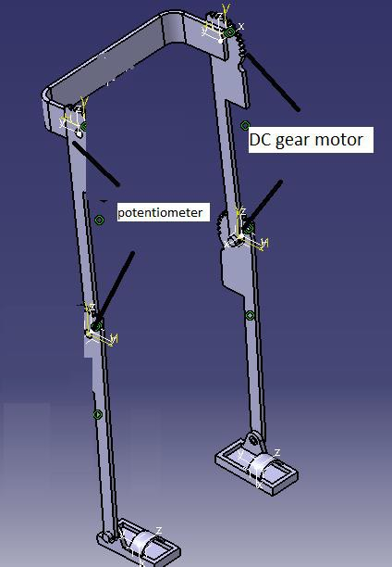

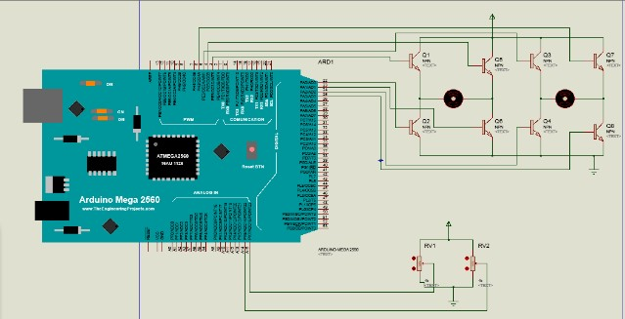Fig.1

Fig.2

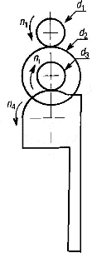

The direct kinematics locates the Cartesian coordinates from the joint rotation angles.



*Direct kinematics*

ɵ1, ɵ2 and ɵ3

are given

Find x, y, z of the point A

To precede this study we use the **Denavit*–*Hartenberg** convention. The **DH** parameters for the left limb in the following table:

|  |  |  |  |  |
| --- | --- | --- | --- | --- |
|  | ɵi | di | ai | αi |
| Link 1 | ɵ1 | 0 | l1 | 0 |
| Link 2 | ɵ2 | 0 | l2 | 0 |

.

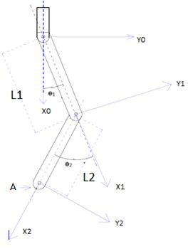

Fig.6 Frames representation on the left limb

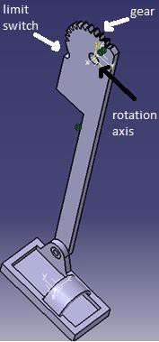Fig.4

1. **MODELING APPROACH:**

## Kinematic model:

Fig.5

Transformation matrices T :

### cos(ɵ1+ɵ2) -sin (ɵ1+ɵ2) 0 l1cosɵ1+l2cos (ɵ1+ɵ2) T= sin(ɵ1+ɵ2) cos (ɵ1+ ɵ2) 0 l1sinɵ1+l2sin(ɵ1+ɵ2)

0 0 1 0

### 0 0 0 1

The last column of the transformation matrix represents the Cartesian coordinates (x, y, z) of the point A :

The kinematics model associate the Cartesian coordinate

(x,y,z) to the joint angle of the exoskeleton (ɵ1,ɵ2) . This model provides the control's rule that we need to embed in the Arduino board to define the angle rotation of the two motors from the coordinate x and y required. They are two- kinematics model: the direct kinematics and the inverse kinematics model.

## direct kinematics:

xA = l1 cos ɵ1 + l2 cos(ɵ1+ ɵ2) yA = l1 sin ɵ1 + l2 sin(ɵ1+ ɵ2) zA= 0

## Simulation Matlab:

Petercorke [9] developed a Robotics toolbox in MATLAB used for kinematics and dynamics simulation for robotics systems.

The **NOD-H** exoskeleton joints length: l1=40, l2=50.

### ɵ1 = π/4 ɵ2= -π/4

Transformation matrices T1 computed is:

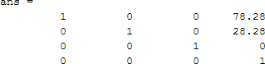

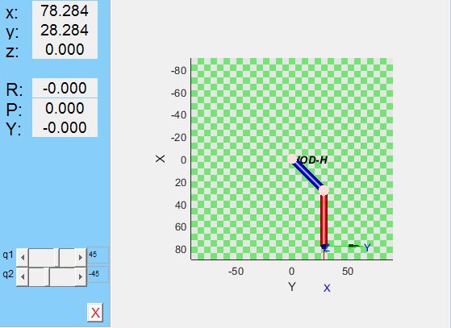

Fig.7

x= 78.284; y=28.284

### ɵ1 = π/6 ɵ2= -π/6

Transformation matrices T2 :

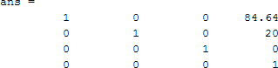

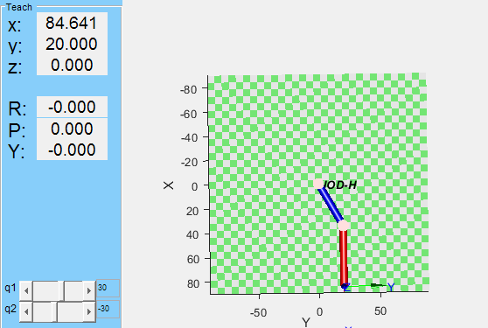

Fig.8

x= 84.641; y=20

This model compute (x, y, z) for a ɵ1 and ɵ2 given.

## inverse kinematics:

During the gait, the exoskeleton cross several trajectories, each one require different values of joint rotation angles ɵ1 and ɵ2. Inverse kinematics model provides the values of the angles ɵ1 and ɵ2 for a specific trajectory (x, y) of the last point in the exoskeleton.

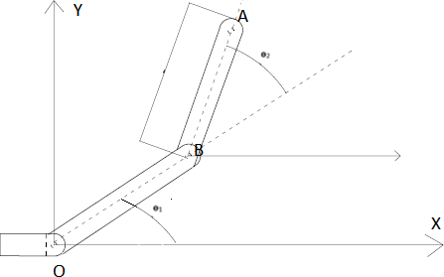

Fig.9

* ɵ2 calculation :

By using the Pythagorean law in fig.9, we have: (OA) 2 = x2 + y2 (Eq.1)

We apply the Cosine Rule we obtain:

Eq.2)



(

We substitute OA from Eq.1 in Eq2 we obtain: x2+y2= (l1)2+(l2)2– 2*l1*l2*cos(π-ɵ2) (Eq.3)

As we know : cos (π-ɵ2) = - cos (ɵ2) so:

x2 + y2= (l1)2 + (l2)2 + 2* l1 *l2* cos (ɵ2) and the ɵ2 equation will be:

(Eq.4)

* ɵ1 calculation :

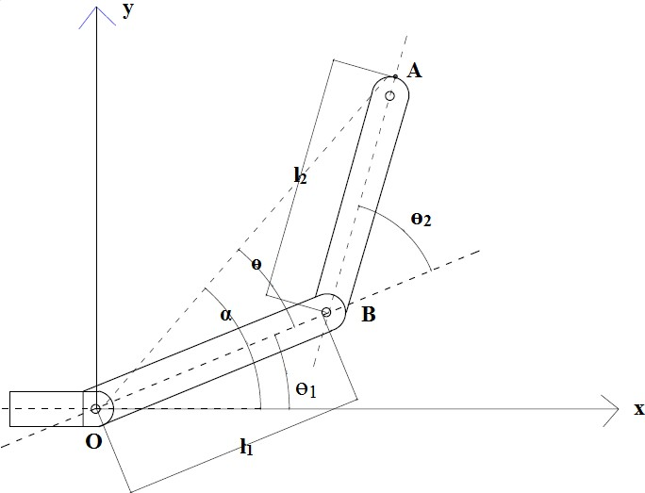

Fig.10

α= ɵ + ɵ ; ( )  ;

1

IDM

The IDM express the torque as a function of the joint angle

𝜃, joint speed𝜃̇ and Joint acceleration 𝜃̈ .



To determine this equation we use Euler-Lagrange formalism.

The Lagrangian function equation is:

E*p*

E*p:* Potential energy

: Kinetic energy

The torque in junction i can be calculated using the following equation:

Using the sin law, we have:

( ) ( )

( )

√

( )

* + Kinetic energy Calculation:

= K1 + K2

√ 2 2

√

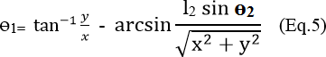

If (x, y) are known, the equation Eq.4 and Eq.5 compute the rotation angle ɵ1 and ɵ2

## Dynamic system modeling

The objective of dynamic modeling is to attain the control law of the exoskeleton. It describe the equations between the torques exerted by the actuators on the joints and the angles, speeds and accelerations of the structure [10]. Two method are known to get the equations: The Euler- Lagrange method and Newton-Euler method [11].

## inverse dynamics model:

= m1v1 + m2v2

Observing the fig.11, we have: x1= OG1 *cos (ɵ1) ;

y1 = OG1*sin (ɵ1) ;

x2= L1 cos (ɵ1) + BG2 cos ( ) y2 = L1 sin (ɵ1) + BG2 sin ( )

= 𝜃1+ 𝜃2

The inverse dynamics model (IDM) defines the equations for estimating the motors torques required for a known motion of the exoskeleton, it express the forces and torques in every articulation of the system, according with the evolution of the articular coordinates and their derivatives (𝜃, 𝜃̇, 𝜃̈) :

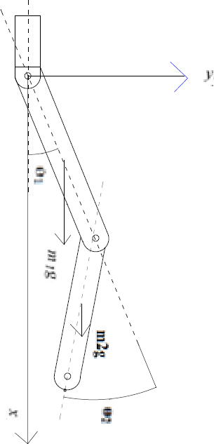Fig.11



# Motion:

Compute 73

# 𝜃, 𝜃̇,

𝜃̈

torque𝜏

IJSTR©2018

[www.ijstr.org](http://www.ijstr.org/)

̇1= -OG1 * ̇1*sin ( 1) ;

̇1= OG1* ̇1*cos ( 1)

The torque for joint 1, τ1, is obtained by deriving Eq. (8) with respect to θ1:

̇2= - [L1* ̇1*sin ( 1)+BG2( ̇ )*sin ( )]

̇2= L1* ̇1*cos ( 1) + BG2( ̇ )*cos ( )

L

is the partial derivation of the Lagrangian function in

Eq.8:

We conclude the speed :

L 𝑙

𝐿

 𝜃 = *m1g sin (*𝜃*1) +m2gL1sin (*𝜃*1) + m2g sin (*𝜃*1+*𝜃*2)* Eq.9

The time derivative is:

b = m1 ( ) 2 + m2 (L1)2+ m2 ( ) 2

𝜃̇

𝐿

cos (𝜃2) - m2L1L2𝜃̇1𝜃̇2sin (𝜃2) - m2L1 𝜃̇22sin (𝜃2) Eq.10

L b𝜃 + m

1

̈ 𝐿 ̈ ̈ 𝐿

2

𝜃2 + m2 L

1 L

2 𝜃1 cos (

𝜃2

) + m2

L

1 𝜃2

V22 = (L1𝜃̇1)2 + ( 𝜃1

𝐿

𝐿

𝐿

𝐿

) + ( 𝜃̇2) 2 + 𝜃1𝜃2

2

̇

+2L

1 𝜃̇12cos (𝜃2) +

2L1 𝜃̇1𝜃̇2cos (𝜃2)

𝐿

The torque on the hip is calculated by the subtraction of the equation Eq.10 and Eq.9, the result will be:

In addition:

## knee torque calculation:

So the Kinetic energy expression is :

τ bθ̈ +

1 1 m2

θ2 + m L L

L

2 1 2 1

θ cos(

θ2

) + m L

2 1 θ2 cos

L

(θ2

) - m L L

2 1 2 1 2

θ θ sin (

̇

θ2

) - m L

2 1 θ2 sin (

L

̇ 2

θ

l

2) - m1g sin

L

(

𝜃

= -m2L

1 𝜃1 𝜃2 sin(

𝐿

̇ 2

𝜃2)-m2L

1 𝜃1

𝐿

̇

𝜃2 sin(

2

𝜃2) +

*m2g* 𝜃̇2*sin(*𝜃*1+*𝜃*2)*

𝐿

Eq.12

𝐿

𝐿

𝐿

𝐾 = m1 ( ) 2 * 𝜃̇12 + m2(L1𝜃̇1)2 + m2 ( 𝜃̇1) 2 + m2( 𝜃̇2) 2

L

θ1) - m2gL1sin (θ1) - m2g sin (θ1+θ2) Eq.11

𝐿

𝐿

𝐿

+ m2

•

𝜃̇1𝜃̇2+m2L1 𝜃̇12cos(𝜃2) + m2L1 𝜃̇1𝜃̇2cos (𝜃2) Potential energy Calculation:

The same procedure is applied for the knee joints the partial

Ep= Ep1 + Ep2

derivative

L

is:

Ep= m1gh1+ m2gh2

h1= x1 and h2= x2

L

The torque on the knee can be calculated by the equation:

The equation of the torque can be written:

L τ=*M*( ) ̈ + C (𝜃̇, )+ G (𝜃)

Ep = m1 g

* cos (θ1) + m2 g L1 cos (θ1) + m2 g

cos(θ1+θ2) Eq.7

̇ m2(

L 𝐿

𝐿

𝐿

𝜃

m 𝐿 ̇ ̇

) 2 𝜃̈2 + m2

𝜃̈1+m2L1

𝜃̈1cos(𝜃2) -

We replace h

1 and h2 by their expression we find:

2L1 𝜃1𝜃2sin (𝜃2) Eq.13

The Lagrangian function obtained by summarization of Eq.6 and Eq.7:

𝐿 𝐿

𝐿

𝐿

𝐿

m1 (

) 2 𝜃12 +

m2 [(L1𝜃1)2 + (

𝜃1) 2 + (

𝑙

𝜃2) 2 +

𝜃1𝜃2

̇ 2

+L1L2𝜃1 cos (𝜃2) + L1L2𝜃1𝜃2cos (𝜃2)] - *m1g cos (*𝜃*1) m2gL1cos (*𝜃*1)*

𝐿

*- m2g cos(*𝜃*1+*𝜃*2)* Eq.8

* **Hip torque calculation** τ1**:**

M( ) : Masse Matrice

C (𝜃̇, ) : velocity product matrix G (𝜃) gravity matrix

τ1

τ2 m2 ( ) 𝜃2 + m2

𝐿 𝐿

2

𝜃̈1 + m2L1 𝜃̈1cos(𝜃2) - m2L1 𝜃̇1𝜃̇2sin

𝐿

𝐿

(𝜃 )

2 + m L

2 1 𝜃1 𝜃2

𝐿

̇ 2

sin (

𝜃2

) + m L

Eq.14

2 1 𝜃1 2

𝐿

̇

𝜃 sin (

2

𝜃2) -

*m2g* 𝜃̇2*sin(*𝜃*1+*𝜃*2)*

𝐿

L

̇

L

Eq.11 and Eq.14 provides the IDM, its compute the torque on the hip and the knee for an angle, speed and acceleration given on the hip and knee.

## forward dynamics model:

Forward dynamics model calculate the joint acceleration

𝜃̈for a known angle joint 𝜃, speed rotation of the joint𝜃̇, and

torque actuator in this joint τ. This model is useful to know the acceleration of the exoskeleton for defined trajectory.

*FDM*



Motion:

𝜃, 𝜃̇, 𝜏

Compute acceleration𝜃̈

To find the expression of the acceleration 𝜃̈1 and 𝜃̈2 we use the equation Eq.11 and Eq.14

𝜃̈ (𝜃, 𝜃̇, )

In this research, we gave more importance to the inverse dynamics model IDM because it contribute in the control rule, the IDM calculate the required torque for a given motion.

The inverse kinematics model (IKM) and the inverse dynamics model (IDM) provides the rule control for the exoskeleton. The trajectory defined by group of successive coordinates (xi, yi), the IKM calculate the angle joint 𝜃1i and

𝜃2i for each pair (xi, yi).In addition, the IDM calculate the torque joint to achieve the next joint angle (𝜃1i, 𝜃2i).

IDM



IKM

Calculate ɵ1i, ɵ2i

(xi ,yi) of the trajectory



Compute torque𝜏

1. **DOUBLE TORSION SPRING:**

Using a Double Torsion Spring DTS in the knee joint offer an alternative power source for the exoskeleton. In fact, the gear-motor installed in the knee joint provides only the difference between the torque requested for the motion and the torque released by the DTS. Moreover, the motor size and gearbox can be smaller, and the exoskeleton can be lightest. Otherwise, the peak power demand on the motor and the energy consumption can be reduced which increase the lifetime of the batteries [12].At the sitting stage, the patient’s mass provide the necessary torque to compress the spring, this torque stored in the form of potential energy, which is restored during the return to stand-up position. The same sequence happen during the walking phases, the spring store a potential energy when ɵ2 increasing, and release this energy when ɵ2 decreasing. The DTS torque expression is τs=K*ɵ

K: torsion coefficient

Ɵ: Angle of deflection from rest position

The following graph describe the influence of the spring torque during the sit to stand (STS) transition:

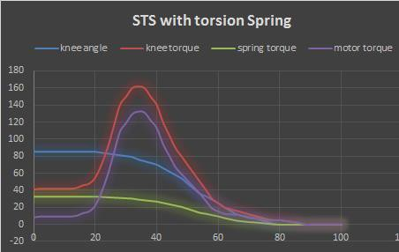

Fig.10 the knee angle and the knee torque in the STS motion plotted for a 75 kg person with the data from [13]. The spring torque plotted for a DTS with a K= 22Nm/rad.

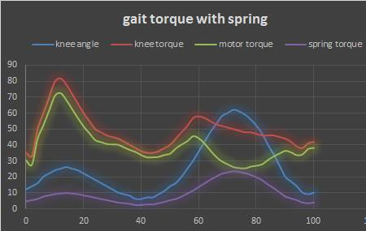

Fig.11 the knee angle and the knee torque for a Normal biomechanical gait plotted for an 85 kg person with the data from [14]. The spring torque plotted for a DTS with a K= 22Nm/rad.

The previous graphs shows the profit of adding the DTS to the knee joint actuation. It reduces the motor requested torque by 33% on Sit to stand transition and 20% during normal gait. This result allows choosing a smaller gear- motor, which reduce the batteries consumption and minimize the total weight of the exoskeleton.

1. **CONTROL SYSTEM :**

Great progress made in the control of exoskeletons, many solutions are already implemented, HAL project use a cane contain a sensor as a tool for motion detection and motion intention estimation [4]. Kawamoto [5] developed a control system for the HAL by using FRF sensors to detect the user walk intention. Krausser and Kazerooni [6] developed another Human Machine Interface for paraplegic people with an exoskeleton robot (eLEGS).

In the proposed prototype, we purpose to use a self- learning approach of angle and speed rotation for control of

the exoskeleton suit. The potentiometer and the buttons attached to unaffected leg provide the information about the intention motion of the patient. The microcontroller ATmega uses this information to calculate the patient speed motion and generate the intended motion in the affected side using the same speed. Which make the walking more comfortable for the hemiplegic person. The average comfortable walking speed usually varies between 1.2m/s and 1.6m/s. However, this speed differs from person to another. If a person needs get to a destination under time pressure, walking speed increases. [8]. Moreover, the motion of the affected leg must to be more harmonic with the unaffected leg; the angle joint 𝜃1 and 𝜃2 in the right leg must to be the same in the left leg, any gap between the angles embarrass the patient in the gait.

The following scheme describe the algorithm control used for the exoskeleton:

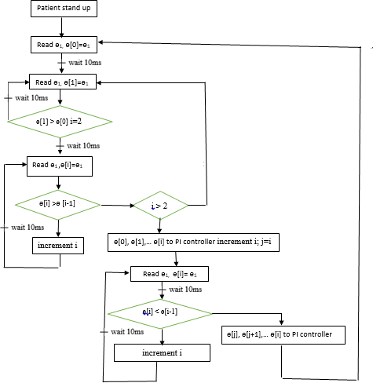

Fig.12 NOD-H algorithm control

A double control system implemented for the exoskeleton to control the position joints angle and the speed motion. The aim of this system is to control the speed of movement in a position control. The following figure show the Block diagram of the double control system:

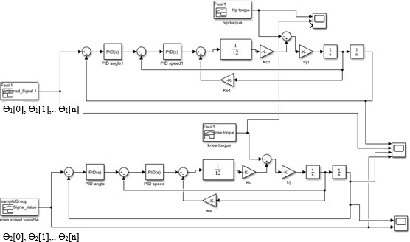

Fig.13 Block diagram double PI control system

The simulation on Matlab shown the following results:

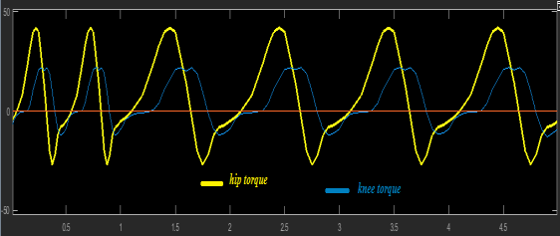

Fig.14 Knee torque and hip torque for various speed for a 75 kg person with the data from [15]

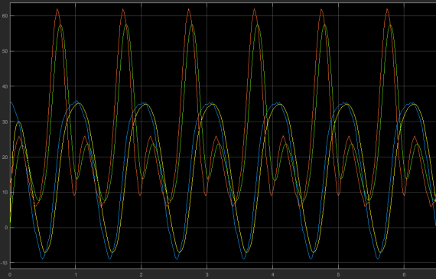

Fig.15 Knee and hip angle control: angle kp=2 ki=0.15: speed constant, zero torque

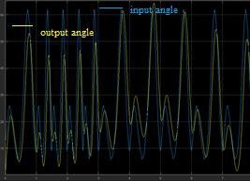

Fig.16 Knee angle control: kp= 2 ki= 0.15 variable speed, zero torque

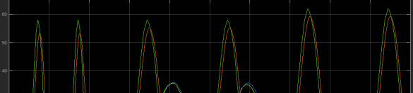

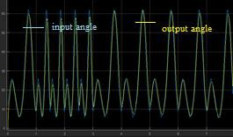Fig.17 Knee angle control: kp= 10 ki= 0.15 variable speed, zero torque

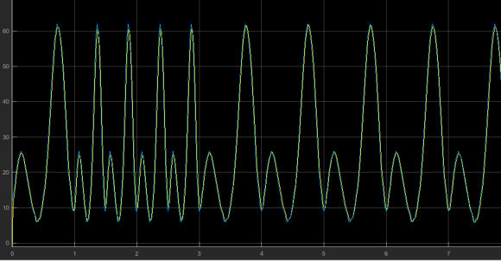

Fig.18 Knee angle control: kp= 20 ki= 0.15 variable speed zero torque

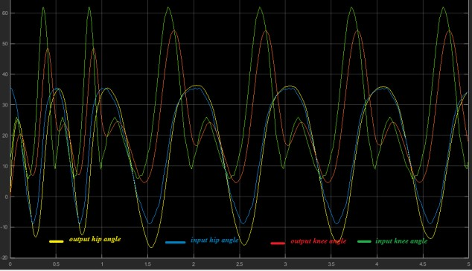

Fig.19 Knee and hip angle control: angle kp= 2 ki= 0.15 : various speed, with torque variation

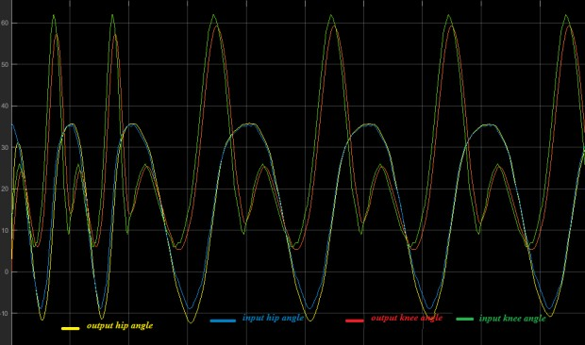

Fig.20 Knee and hip angle control: angle kp= 20 ki= 0.15 : various speed, with torque variation

Fig.21 Knee and hip angle control: various speed, various torque and several angle limits for knee and the hip kp=10 ki= 0.15

1. **ANALYSIS AND DISCUSSION:**

The Fig.15 shows the input and output angle joints for the knee and the hip for a constant speed and zero torque. The Fig.16, 17 and 18 represent the results of the knee and hip angles for various speed and zero torque. Those curves shows the behavior of system without load. The Fig.19 and

20 represent the results of the knee and hip angle for various speed and various torque. Its present the behavior of the exoskeleton with patient for different walk speed. The speed for the first second is double for the next 3 seconds.

All those curves show that the double control system follow the command in angle and rotation speed. If the patient speed-up the control system increase the speed of the motors to follow the patient motion, which avoid any lag between the right and left legs. In addition, the speed motion on the affected leg will be the same on the unaffected leg.

The Fig.21 represent the results of the knee and hip angle for various speed and various torque and variable maximum joints angle ɵ1 and ɵ2.

In the first 3 seconds, the maximum knee angle is 58, in the next two seconds the maximum knee angle is 64. In the two-time interval, the double control system generates an output angle that corresponds to the input angle. This feature is useful for the system in the case of ascending stairs and sidewalks. First, the patient climb by his unaffected leg, the system read the joints angle ɵ1 and ɵ2 and generate the climb motion on the affected leg using the angle ɵ1 and ɵ2 for climbing motion, which allows the patient to climb the stairs or the sidewalk easily.

1. **CONCLUSION:**

The hemiplegic patients suffer from great leak of mobility. In this study, we present a dynamic powered exoskeleton system designed for hemiplegic patients. This system use a self-learning method to correct the speed motion for the affected leg and to estimate the maximum hip and knee angle which allows the patient to avoid obstacles on the path, climb sidewalks and stairs without using buttons, and makes the walking of the hemiplegic patients more comfortable. This system is more practical than the others solution already exist in the market. In forthcoming works, we will focus our studies on the impact of using this system by Hemiplegia patients in the rehabilitation treatment and

daily life. In addition, we will improve the efficiency and the weight of **NOD-H** by using only one gear motor to provide the needed torque for the hip and the knee. This future study will decrease the expected price of the exoskeleton, which make it more available for large number of patients.

**REFERENCES:**

1. The national rapport of handicap in Morocco, [www.social.gov.ma,](http://www.social.gov.ma/) February 2014.
2. Therapy evaluation and management of patients with hemiplegia. Savinelli. R, Timm. M, Montgomery. J, Milson. Dj; Clinical Orthopaedics and Related Research, 01 March 1978.
3. Kong & Yang, 2006; Pedretti et al. 2001.
4. Wearable gait measurement system with an instrumented cane for exoskeleton control, M. Modar, K. Hideki, S. Kenji and S. Yoshiyuki. Sensors January 2014.
5. Development of single leg version of HAL for hemiplegia. in proceedings of the annual international conference of the IEEE engineering in medicine and biology society (embc), Minneapolis, USA, 3–6 September 2009. Kawamoto, H.Hayashi, T.Sakurai, T.Eguchi, K.Sankai.
6. The development and testing of a human machine interface for a mobile medical exoskeleton. In proceedings of the IEEE/RSJ international conference on intelligent robots and systems (IROS), San Francisco, USA, 25-30 September 2011; Strausser K.A, Kazerooni H.
7. “Biomechanical design of the berkeley lower extremity exoskeleton g (bleex),” IEEE/ASME trans. mechatronics, vol. 11, no. 2, pp. 128–138, 2006. a. b. Zoss, H. Kazerooni, and A. Chu.
8. Human walking behavior, the effect of pedestrian flow and personal space invasions on walking speed and direction. A. Frohnwieser, R. Hopf, E. Oberzaucher, department of anthropology, university of Vienna, 2cf- computer gmbh, Vienna, Austria. Human Ethology Bulletin 28 (2013)
9. <http://petercorke.com/wordpress/>(15 June 2018).
10. Modeling, identification and control of robots. kogan page science, 2d edition, 2004. 27. W. Khalil et E. Dombre.
11. Dynamic modelling and simulation for control of a cylindrical robotic manipulator. A. Iqbal and S. M. Athar.

March 1995

1. Spring uses in exoskeleton actuation design. S. Wang,

H.V.D. Kooij article in IEEE international conference on

rehabilitation robotics. 2011 IEEE International Conference on Rehabilitation Robotics.

1. Whole-body movements during rising to standing from sitting. Physical therapy. vol. 70, no. 10, pp. 638–648, 1990.

M. Schenkman, R.A. Berger, P. O. Riley, R. W. Mann, and

W. A. Hodge.

1. Energy cost of walking measurements in 96 subjects with lower limb amputations: a comparison study between floor and treadmill test, gait & posture. vol. 27, no. 1, pp. 70-75, Jan 2008. M. Traballesi, P. Porcacchia, T. Averna, and

S. Brunelli,

1. A method to accurately estimate the muscular torques of human wearing exoskeletons by torque sensors. B. Hwang and D. Jeon Department of Mechanical Engineering, Sogang University, Seoul 121-742, Korea. Sensors 2015.